Deploy ECS/Fargate Infrastructure Using Terraform
This lab walks you, step by step, through deploying a simple containerized application on AWS ECS Fargate using Terraform. It uses a public NGINX image so you don't need any Docker experience to complete it — you'll build real, working infrastructure (networking, load balancing, logging) using only Terraform and the AWS CLI.

What You Will Build
By completing this lab, you will:
- Create a VPC with public and private subnets across two Availability Zones
- Set up an Internet Gateway and a NAT Gateway
- Create security groups that only allow the traffic that's actually needed
- Create an IAM role that lets ECS pull images and write logs
- Deploy a container on ECS Fargate — with no EC2 servers to manage
- Put an Application Load Balancer in front of it
- Send container logs to CloudWatch
- Verify the app is running, scale it up, and clean everything up

2. Architecture Overview
Users reach your application through an Application Load Balancer (ALB) sitting in public subnets. The ALB forwards traffic to ECS Fargate tasks running in private subnets, which have no direct exposure to the internet. The private subnets reach the internet only outbound, through a NAT Gateway, to pull the container image and talk to AWS services.
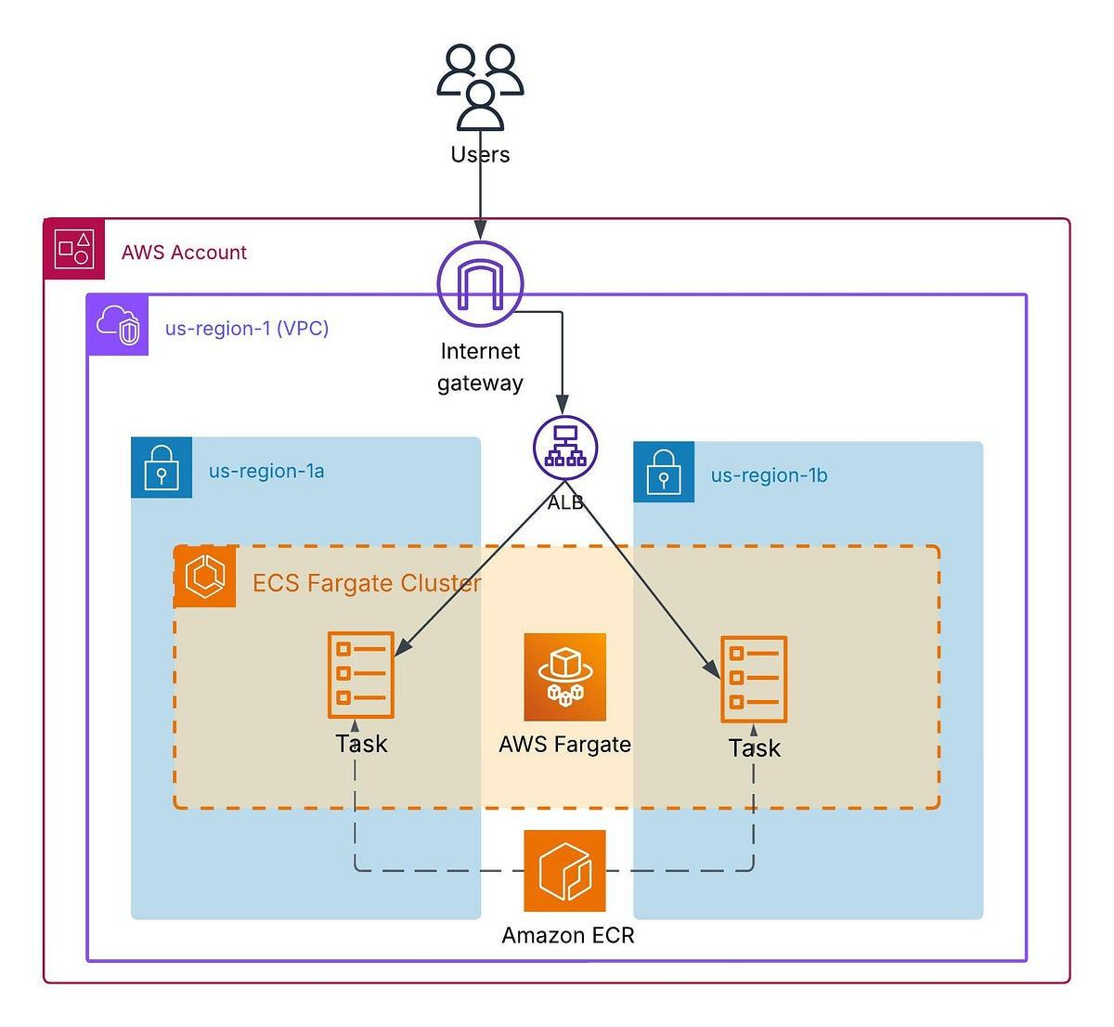

3. Create the Project Directory
mkdir ecs-fargate-terraform
cd ecs-fargate-terraform
You will create the following files inside it, one section at a time:
ecs-fargate-terraform/
├── provider.tf
├── variables.tf
├── vpc.tf
├── security-groups.tf
├── ecr.tf
├── iam.tf
├── alb.tf
├── ecs.tf
├── outputs.tf
└── terraform.tfvars

4. Create the Terraform Provider
Create provider.tf:
terraform {
required_version = ">= 1.5.0"

required_providers {
aws = {
source = "hashicorp/aws"
version = "~> 6.0"
}
}
}

provider "aws" {
region = var.aws_region
}

5. Create Variables
Create variables.tf:
variable "aws_region" {
description = "AWS region"
type = string
default = "ap-south-1"
}

variable "project_name" {
description = "Project name"
type = string
default = "ecs-fargate-demo"
}

variable "vpc_cidr" {
description = "VPC CIDR block"
type = string
default = "10.0.0.0/16"
}

variable "container_port" {
description = "Container port"
type = number
default = 80
}

variable "desired_count" {
description = "Number of ECS tasks"
type = number
default = 2
}

6. Create the VPC and Networking
Create vpc.tf:
data "aws_availability_zones" "available" {
state = "available"
}

resource "aws_vpc" "main" {
cidr_block = var.vpc_cidr
enable_dns_support = true
enable_dns_hostnames = true

tags = {
Name = "${var.project_name}-vpc"
}
}

resource "aws_internet_gateway" "igw" {
vpc_id = aws_vpc.main.id

tags = {
Name = "${var.project_name}-igw"
}
}

resource "aws_subnet" "public_a" {
vpc_id = aws_vpc.main.id
cidr_block = "10.0.1.0/24"
availability_zone = data.aws_availability_zones.available.names[0]
map_public_ip_on_launch = true

tags = {
Name = "${var.project_name}-public-a"
}
}

resource "aws_subnet" "public_b" {
vpc_id = aws_vpc.main.id
cidr_block = "10.0.2.0/24"
availability_zone = data.aws_availability_zones.available.names[1]
map_public_ip_on_launch = true

tags = {
Name = "${var.project_name}-public-b"
}
}

resource "aws_subnet" "private_a" {
vpc_id = aws_vpc.main.id
cidr_block = "10.0.11.0/24"
availability_zone = data.aws_availability_zones.available.names[0]

tags = {
Name = "${var.project_name}-private-a"
}
}

resource "aws_subnet" "private_b" {
vpc_id = aws_vpc.main.id
cidr_block = "10.0.12.0/24"
availability_zone = data.aws_availability_zones.available.names[1]

tags = {
Name = "${var.project_name}-private-b"
}
}

resource "aws_route_table" "public" {
vpc_id = aws_vpc.main.id

route {
cidr_block = "0.0.0.0/0"
gateway_id = aws_internet_gateway.igw.id
}

tags = {
Name = "${var.project_name}-public-rt"
}
}

resource "aws_route_table_association" "public_a" {
subnet_id = aws_subnet.public_a.id
route_table_id = aws_route_table.public.id
}

resource "aws_route_table_association" "public_b" {
subnet_id = aws_subnet.public_b.id
route_table_id = aws_route_table.public.id
}

resource "aws_eip" "nat" {
domain = "vpc"

tags = {
Name = "${var.project_name}-nat-eip"
}
}

resource "aws_nat_gateway" "nat" {
allocation_id = aws_eip.nat.id
subnet_id = aws_subnet.public_a.id

depends_on = [
aws_internet_gateway.igw
]

tags = {
Name = "${var.project_name}-nat"
}
}

resource "aws_route_table" "private" {
vpc_id = aws_vpc.main.id

route {
cidr_block = "0.0.0.0/0"
nat_gateway_id = aws_nat_gateway.nat.id
}

tags = {
Name = "${var.project_name}-private-rt"
}
}

resource "aws_route_table_association" "private_a" {
subnet_id = aws_subnet.private_a.id
route_table_id = aws_route_table.private.id
}

resource "aws_route_table_association" "private_b" {
subnet_id = aws_subnet.private_b.id
route_table_id = aws_route_table.private.id
}

7. Create Security Groups
Create security-groups.tf:
resource "aws_security_group" "alb" {
name = "${var.project_name}-alb-sg"
description = "Security group for Application Load Balancer"
vpc_id = aws_vpc.main.id

ingress {
description = "HTTP from Internet"
from_port = 80
to_port = 80
protocol = "tcp"
cidr_blocks = ["0.0.0.0/0"]
}

egress {
description = "Allow outbound traffic"
from_port = 0
to_port = 0
protocol = "-1"
cidr_blocks = ["0.0.0.0/0"]
}

tags = {
Name = "${var.project_name}-alb-sg"
}
}

resource "aws_security_group" "ecs" {
name = "${var.project_name}-ecs-sg"
description = "Security group for ECS tasks"
vpc_id = aws_vpc.main.id

ingress {
description = "HTTP from ALB"
from_port = var.container_port
to_port = var.container_port
protocol = "tcp"
security_groups = [aws_security_group.alb.id]
}

egress {
description = "Allow outbound traffic"
from_port = 0
to_port = 0
protocol = "-1"
cidr_blocks = ["0.0.0.0/0"]
}

tags = {
Name = "${var.project_name}-ecs-sg"
}
}
Note: The ECS security group does not allow traffic from the whole internet — only from the ALB security group, on the container port. This is what keeps your containers from being reachable directly.

8. Create an ECR Repository
Create ecr.tf:
resource "aws_ecr_repository" "app" {
name = var.project_name
image_tag_mutability = "MUTABLE"

image_scanning_configuration {
scan_on_push = true
}

tags = {
Name = var.project_name
}
}
This creates a private Amazon ECR repository. This lab does not use it yet — it runs a public NGINX image so you can focus on ECS and Terraform first. The repository is here so it's ready when you want to deploy your own application later (see "Next Steps" at the end of this lab).

9. Create the IAM Role
Create iam.tf:
resource "aws_iam_role" "ecs_task_execution" {
name = "${var.project_name}-ecs-execution-role"

assume_role_policy = jsonencode({
Version = "2012-10-17"
Statement = [
{
Effect = "Allow"
Principal = {
Service = "ecs-tasks.amazonaws.com"
}
Action = "sts:AssumeRole"
}
]
})

tags = {
Name = "${var.project_name}-ecs-execution-role"
}
}

resource "aws_iam_role_policy_attachment" "ecs_task_execution" {
role = aws_iam_role.ecs_task_execution.name
policy_arn = "arn:aws:iam::aws:policy/service-role/AmazonECSTaskExecutionRolePolicy"
}
This execution role allows ECS to pull images, send container logs to CloudWatch, and perform the other operations it needs to start your tasks.

10. Build ecs.tf: Logging, Cluster, and Task Definition
You'll add three things to ecs.tf one at a time. Start with the CloudWatch log group:
resource "aws_cloudwatch_log_group" "ecs" {
name = "/ecs/${var.project_name}"
retention_in_days = 7

tags = {
Name = "${var.project_name}-logs"
}
}
Add the ECS cluster
resource "aws_ecs_cluster" "main" {
name = "${var.project_name}-cluster"

setting {
name = "containerInsights"
value = "enabled"
}

tags = {
Name = "${var.project_name}-cluster"
}
}
Add the task definition
resource "aws_ecs_task_definition" "app" {
family = var.project_name
network_mode = "awsvpc"
requires_compatibilities = ["FARGATE"]
cpu = "256"
memory = "512"
execution_role_arn = aws_iam_role.ecs_task_execution.arn

container_definitions = jsonencode([
{
name = "nginx"
image = "nginx:latest"
essential = true

portMappings = [
{
containerPort = var.container_port
hostPort = var.container_port
protocol = "tcp"
}
]

logConfiguration = {
logDriver = "awslogs"
options = {
awslogs-group = aws_cloudwatch_log_group.ecs.name
awslogs-region = var.aws_region
awslogs-stream-prefix = "ecs"
}
}
}
])

tags = {
Name = "${var.project_name}-task"
}
}
Note: 256 CPU units and 512 MB memory is the smallest valid Fargate task size — a good, low-cost choice for a lab. The image nginx:latest is pulled from the public Docker registry, which is why no ECR login is needed for this part.

11. Create the Application Load Balancer
Create alb.tf:
resource "aws_lb" "app" {
name = "${var.project_name}-alb"
internal = false
load_balancer_type = "application"
security_groups = [aws_security_group.alb.id]
subnets = [aws_subnet.public_a.id, aws_subnet.public_b.id]

tags = {
Name = "${var.project_name}-alb"
}
}

resource "aws_lb_target_group" "app" {
name = "${var.project_name}-tg"
port = var.container_port
protocol = "HTTP"
target_type = "ip"
vpc_id = aws_vpc.main.id

health_check {
enabled = true
path = "/"
protocol = "HTTP"
matcher = "200-399"
interval = 30
timeout = 5
healthy_threshold = 2
unhealthy_threshold = 3
}

tags = {
Name = "${var.project_name}-tg"
}
}

resource "aws_lb_listener" "http" {
load_balancer_arn = aws_lb.app.arn
port = 80
protocol = "HTTP"

default_action {
type = "forward"
target_group_arn = aws_lb_target_group.app.arn
}
}
Why target_type = "ip"? Fargate tasks use awsvpc networking — each task gets its own network interface and IP address, so the target group needs to track tasks by IP rather than by EC2 instance.

12. Create the ECS Service
Add this to the end of ecs.tf:
resource "aws_ecs_service" "app" {
name = "${var.project_name}-service"
cluster = aws_ecs_cluster.main.id
task_definition = aws_ecs_task_definition.app.arn
desired_count = var.desired_count
launch_type = "FARGATE"

network_configuration {
subnets = [aws_subnet.private_a.id, aws_subnet.private_b.id]
security_groups = [aws_security_group.ecs.id]
assign_public_ip = false
}

load_balancer {
target_group_arn = aws_lb_target_group.app.arn
container_name = "nginx"
container_port = var.container_port
}

depends_on = [
aws_lb_listener.http
]

tags = {
Name = "${var.project_name}-service"
}
}

13. Create Outputs
Create outputs.tf:
output "vpc_id" {
description = "VPC ID"
value = aws_vpc.main.id
}

output "ecs_cluster_name" {
description = "ECS Cluster name"
value = aws_ecs_cluster.main.name
}

output "ecs_service_name" {
description = "ECS Service name"
value = aws_ecs_service.app.name
}

output "ecr_repository_url" {
description = "ECR repository URL"
value = aws_ecr_repository.app.repository_url
}

output "load_balancer_dns" {
description = "Application Load Balancer DNS name"
value = aws_lb.app.dns_name
}

output "application_url" {
description = "Application URL"
value = "http://${aws_lb.app.dns_name}"
}

14. Create the Terraform Variables File
Create terraform.tfvars:
aws_region = "ap-south-1"
project_name = "ecs-fargate-demo"
vpc_cidr = "10.0.0.0/16"
container_port = 80
desired_count = 2
If you're using a different AWS region, change aws_region to match it.

15. Deploy the Infrastructure
a. Initialize Terraform
terraform init
You should see: "Terraform has been successfully initialized!"
b. Format and validate
terraform fmt
terraform validate
You should see: "Success! The configuration is valid."
c. Review the plan
terraform plan
Terraform lists everything it's about to create — the VPC, subnets, gateways, security groups, the ECR repository, IAM role, log group, ECS cluster/task/service, and the load balancer. Read through it before continuing.
d. Apply
terraform apply
Type yes when prompted. This can take several minutes — the NAT Gateway, load balancer, and Fargate tasks all take time to become ready.

16. Test the Application
Once apply finishes, get the application URL:
terraform output application_url
Open the URL in a browser. You should see the NGINX welcome page. You can also test it from the command line:
curl $(terraform output -raw application_url)
The output should contain: <title>Welcome to nginx!</title>
Note: It can take 30–60 seconds after apply finishes for both tasks to pass their first health check. If you get a connection error immediately, wait a minute and try again.

17. Verify Everything in the AWS Console
ECS
AWS Console → ECS → Clusters → ecs-fargate-demo-cluster → Services → ecs-fargate-demo-service. You can see the desired vs. running task count, the task definition in use, and recent events.
Load Balancer
AWS Console → EC2 → Load Balancers → ecs-fargate-demo-alb. Confirm its state is Active. Then go to Target Groups → ecs-fargate-demo-tg → Targets — you should see both targets listed as Healthy.
CloudWatch Logs
AWS Console → CloudWatch → Logs → Log groups → /ecs/ecs-fargate-demo. Open it to see the log streams generated by your running tasks.
You can also check service and task status from the command line:
aws ecs describe-services \
--cluster ecs-fargate-demo-cluster \
--services ecs-fargate-demo-service

aws ecs list-tasks \
--cluster ecs-fargate-demo-cluster \
--service-name ecs-fargate-demo-service

18. Try It Yourself: Scale the Service
In terraform.tfvars, change:
desired_count = 3
Then run:
terraform plan
terraform apply
Check the result:
aws ecs describe-services \
--cluster ecs-fargate-demo-cluster \
--services ecs-fargate-demo-service
You should now see desiredCount = 3 and runningCount = 3 — a third Fargate task, with no servers for you to provision or patch. This is one of the main benefits of Fargate over running ECS on EC2 instances you manage yourself.

19. Clean Up the Environment
Important: The NAT Gateway and load balancer created in this lab are billed by the hour. Destroy the environment as soon as you're done.
terraform destroy
Type yes when prompted. Terraform will remove every resource it created, including the VPC — nothing is left behind. You can confirm this in the console under ECS, EC2 → Load Balancers, ECR, CloudWatch, VPC, and IAM.

20. What You Learned
Component | Purpose
VPC | Provides isolated networking for your resources
Public subnet | Hosts the internet-facing load balancer
Private subnet | Hosts the Fargate tasks, with no direct internet exposure
Internet Gateway | Gives public resources internet connectivity
NAT Gateway | Gives private resources outbound-only internet access
Security group | Controls what network traffic is allowed
ECR | Stores your own container images (ready for later use)
ECS Cluster | A logical grouping of services and tasks
Task definition | Describes how a container should run
Fargate | Serverless compute for containers — no EC2 instances to manage
ECS Service | Keeps the desired number of tasks running
Application Load Balancer | Distributes incoming HTTP traffic across tasks
Target group | Tracks the healthy IP addresses of your Fargate tasks
CloudWatch Logs | Stores your container's log output

21. Troubleshooting
Problem: ECS tasks stay in PENDING
aws ecs describe-services \
--cluster ecs-fargate-demo-cluster \
--services ecs-fargate-demo-service
Look at the service events near the bottom of the output. Common causes:
- A security group is misconfigured
- The private subnet's route table has no route to the NAT Gateway
- The container image can't be pulled
- The task definition has an error
Problem: The ALB returns a 503 error
Check EC2 → Target Groups → ecs-fargate-demo-tg → Targets. If targets show as unhealthy, confirm the ECS security group allows the container port from the ALB security group.
Problem: Tasks can't pull the container image
Check that the private route table has a route for 0.0.0.0/0 pointing at the NAT Gateway. Without it, tasks in the private subnet have no way to reach the internet to pull images.

